Assignment 12

Task Description 1

- Write python code for linear_search () function to search a value in a list and extract its index.

Code:

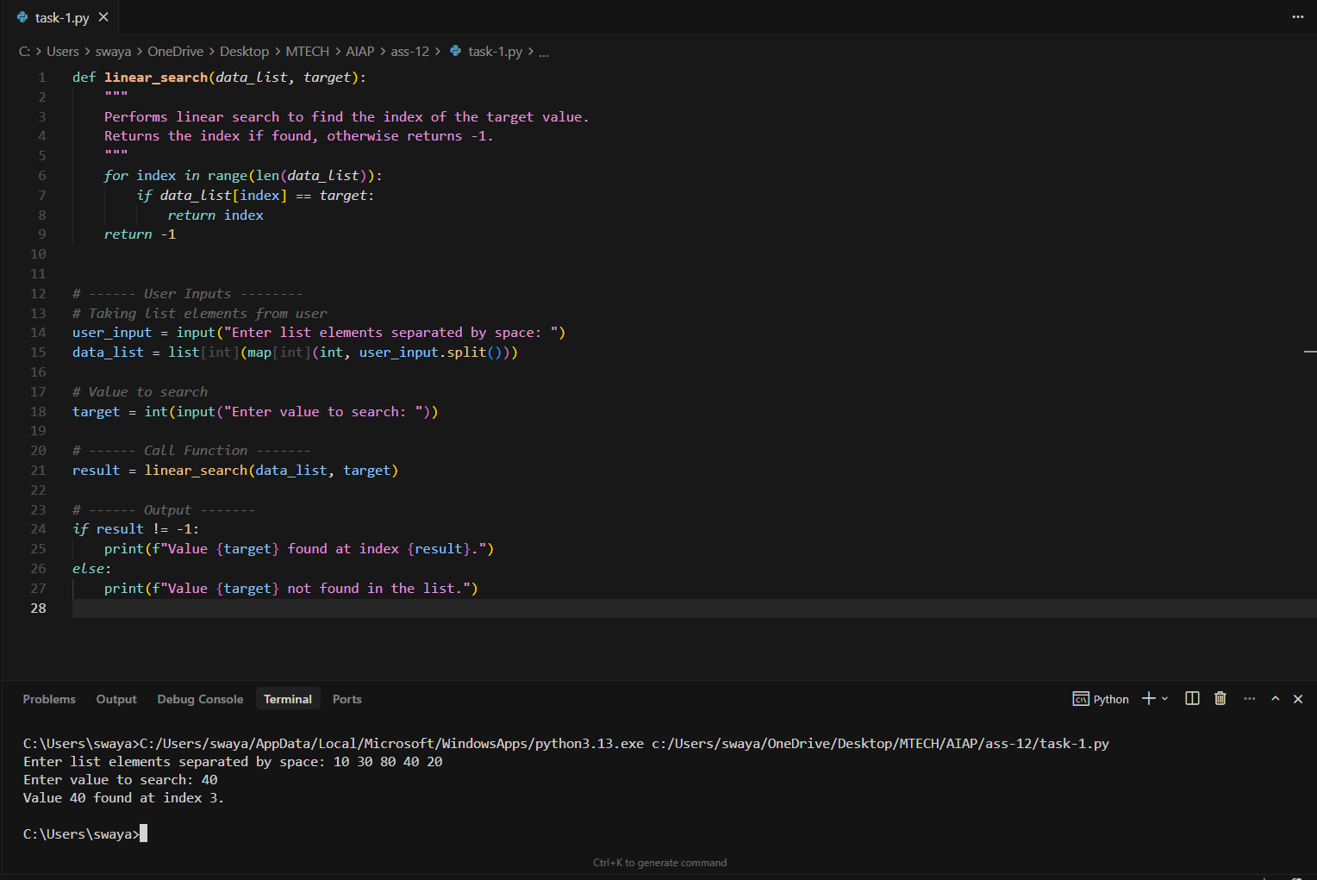

Task Description 2

- Ask AI to implement Bubble Sort and check sorted output

Code:

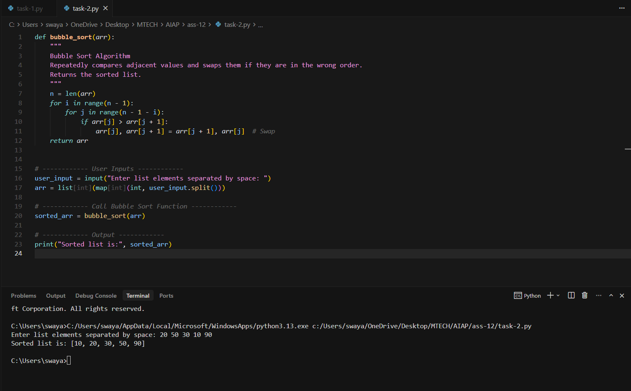

Task Description 3

- Write python code to solve below case study using linear optimization
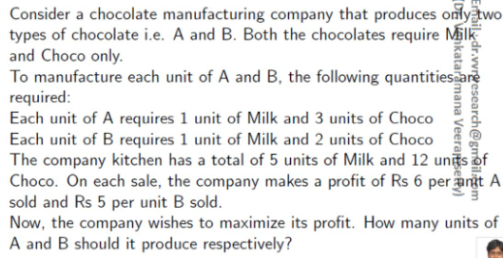

Code:

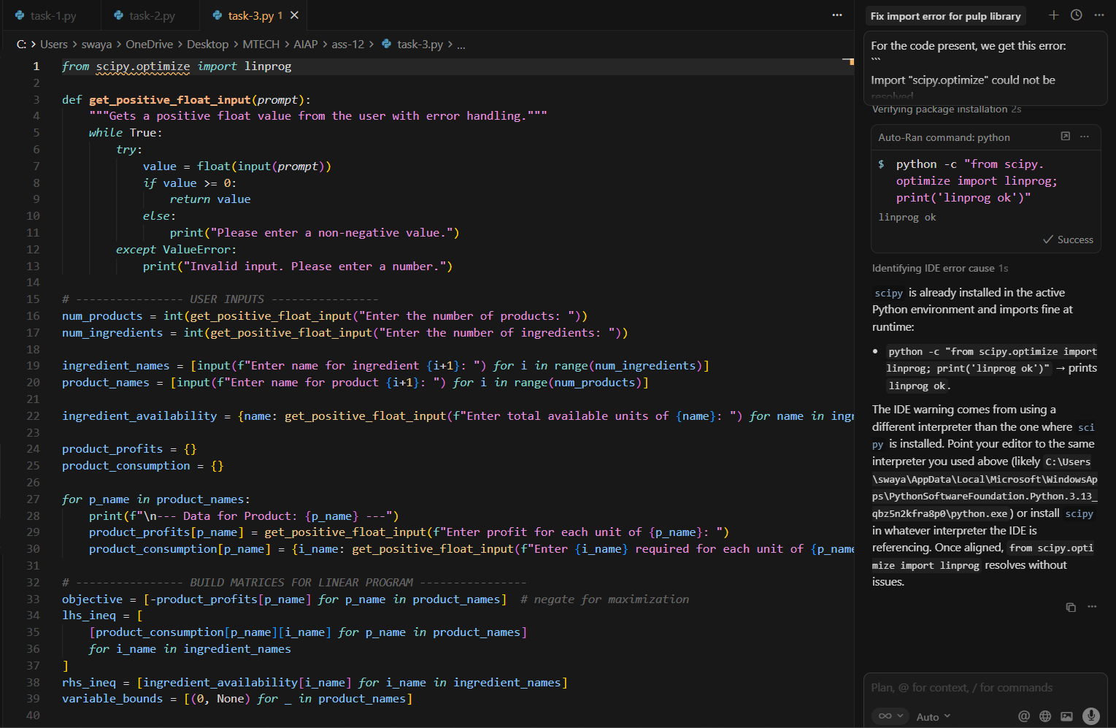

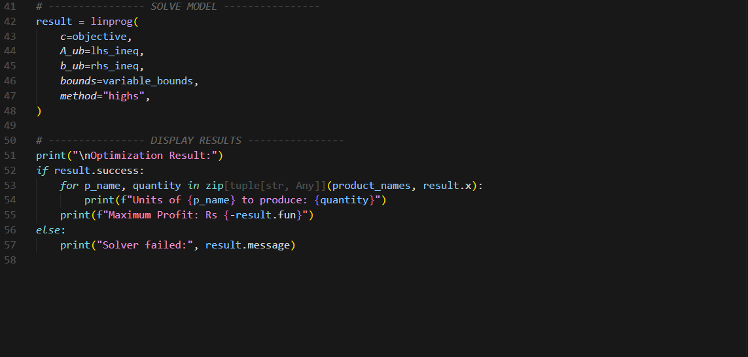

Output:

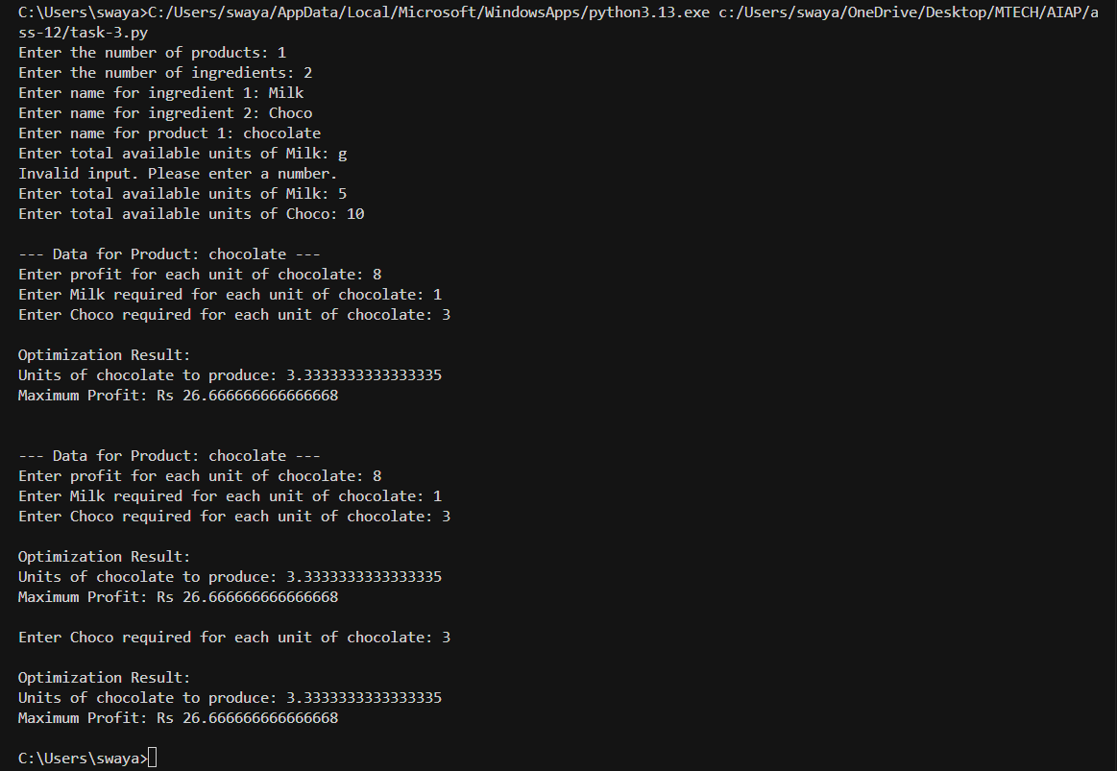

Task Description 4

- Write python code to find value of x at which the function f(x)=2X3+4x+5 will be minimum

Code:

